**DAILY ONLINE ACTIVITIES SUMMARY**

|  |  |  |  |  |  |  |  |  |
| --- | --- | --- | --- | --- | --- | --- | --- | --- |
| **Date:** | **29/05/2020** | | | | | **Name:** | **V ANJANA PAI** | |
| **Sem & Sec** | **IV sem & B section** | | | | | **USN:** | **4AL18CS094** | |
| **Online Test Summary** | | | | | | | | |
| **Subject** | | **OPERATING SYSTEMS** | | | | | | |
| **Max. Marks** | | **30** | | **Score** | | | **29** | |
| **Certification Course Summary** | | | | | | | | |
| **Course** | **1.Python for Machine Learning**  **2. Introduction to Digital Marketing** | | | | | | | |
| **Certificate Provider** | | | **Greatlearning academy** | | **Duration** | | | 1. **5.0 hours** 2. **2.5 hours** |
| **Coding Challenges** | | | | | | | | |
| **Problem Statement1:** Write a Java program to Find size of the largest ‘+’ formed by all ones in a binary matrix  **Problem Statement2:** Write a C Program to generate first N Armstrong Numbers | | | | | | | | |
| **Status: Executed** | | | | | | | | |
| **Uploaded the report in Github** | | | | | **YES** | | | |
| **If yes Repository name** | | | | | **lockdown-coding** | | | |
| **Uploaded the report in slack** | | | | | **YES** | | | |

Online Test Summary: 18CS43 test was scheduled from 9:00 am t0 9:45am. The portion for the IA was 2nd module there were 30 questions and the time assigned was 45 minutes the questions were mcq type.

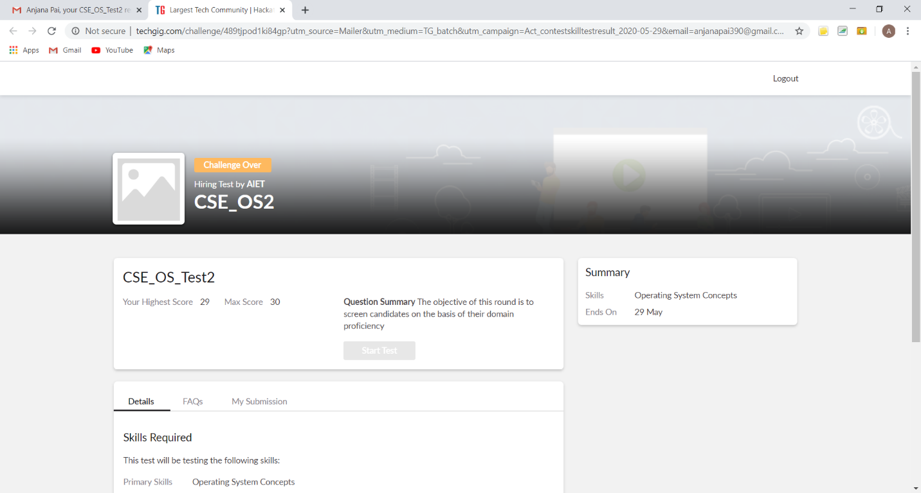

This is the snap shot of completion of test and the marks obtained.

Online Certification Course Summary: In today’s session I completed one of my certificate course Python for Machine Learning by completing the Quiz. Then I registered for another course i.e. Introduction to Digital Marketing from the great learning Academy. Where I learnt about the concepts like Consumer Journey of Today, Explanation of New Medias, Understanding Brand Purpose and Introduction to Facebook Marketing.

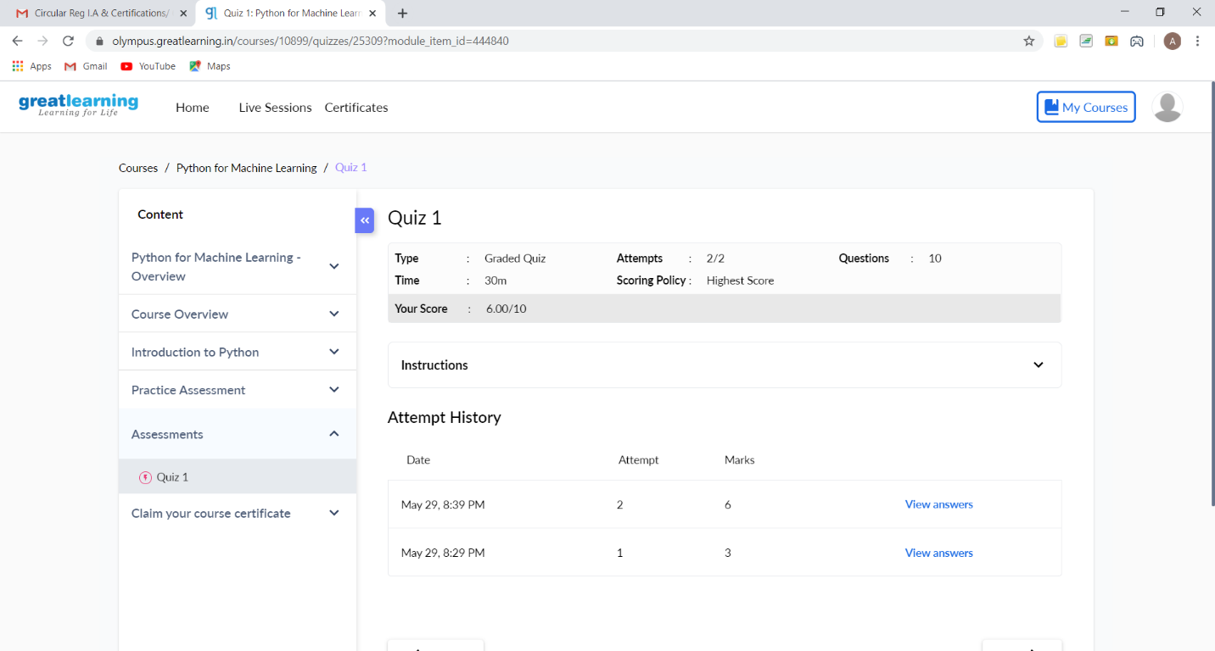

This is the snapshot of quiz attempted.

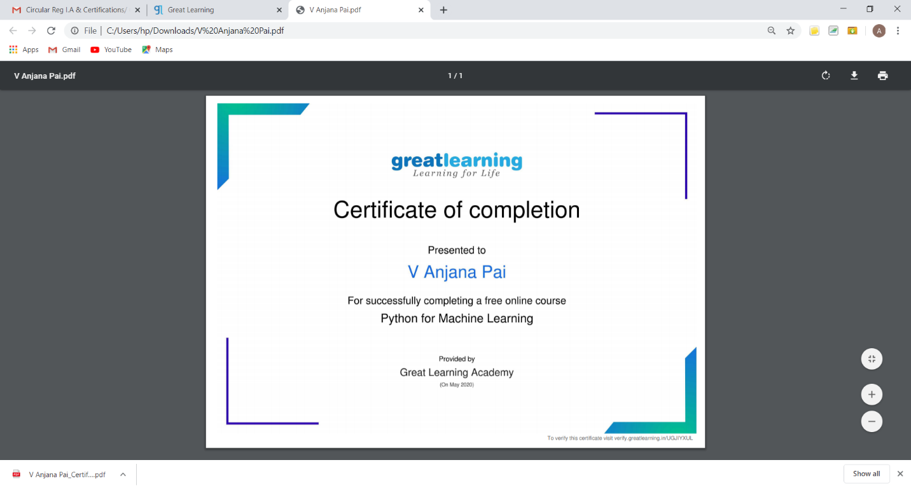

This is the snapshot of the certificate received after completion of course.

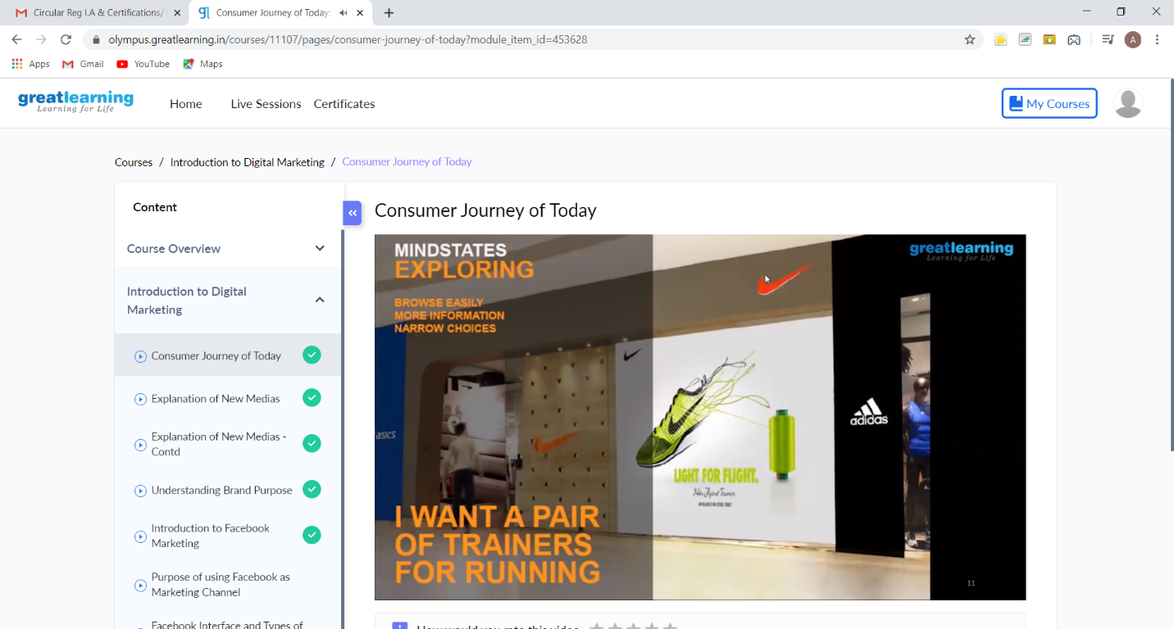

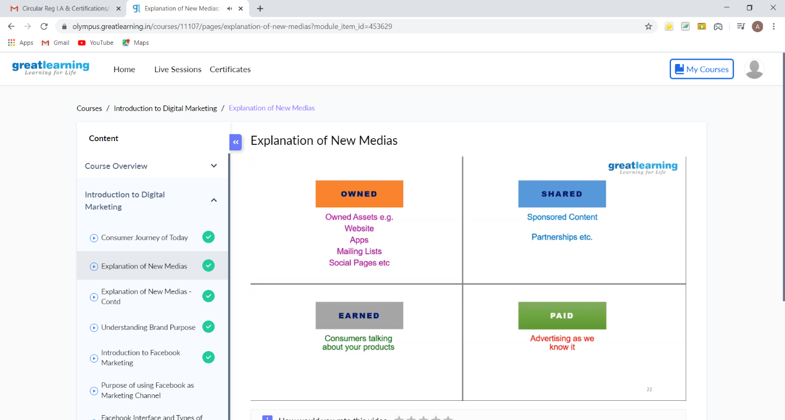

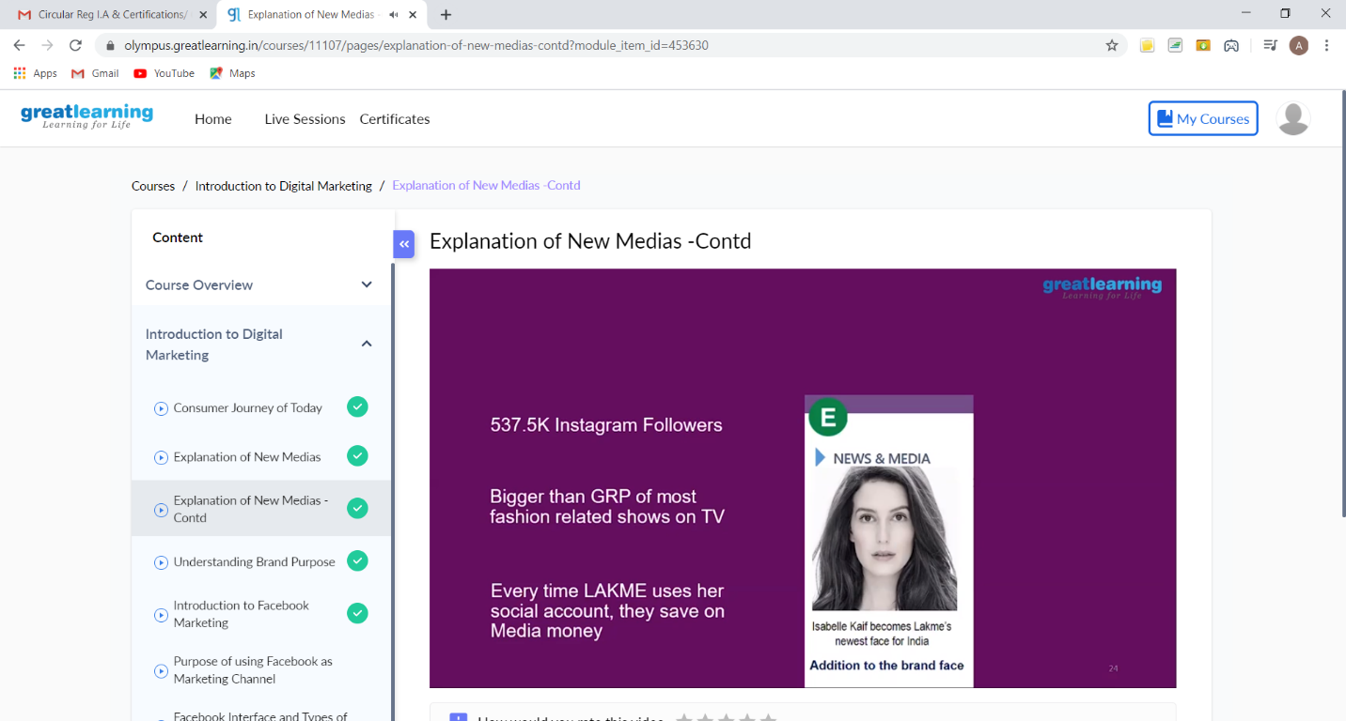

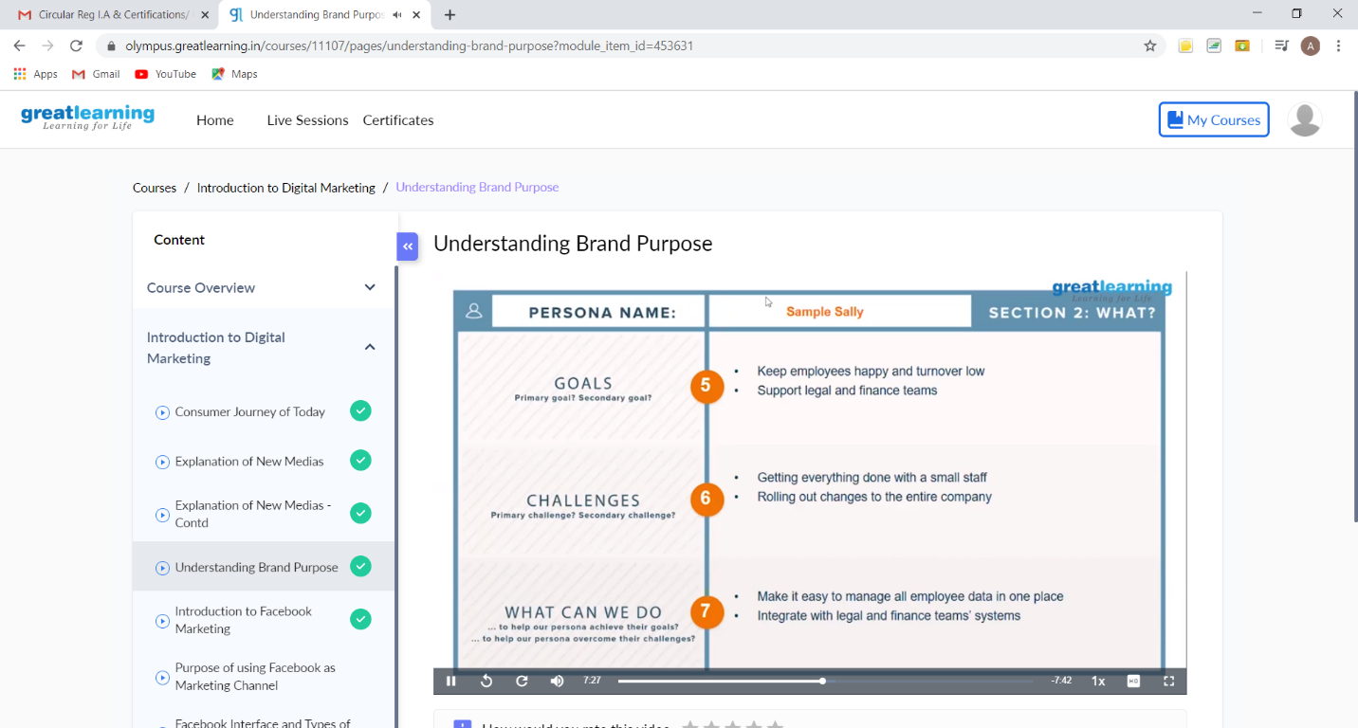

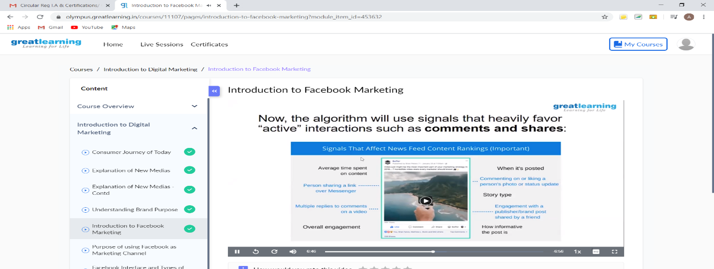

These are the snap shots of today’s session.

Online Coding Summary: **Today I had received one program from prof. Shilpa CSE Dept. and the other from Prof. Venkatesh CSE Dept. The program is mentioned above in the coding challenges(pg.01). I have also uploaded it to my Github repository.**

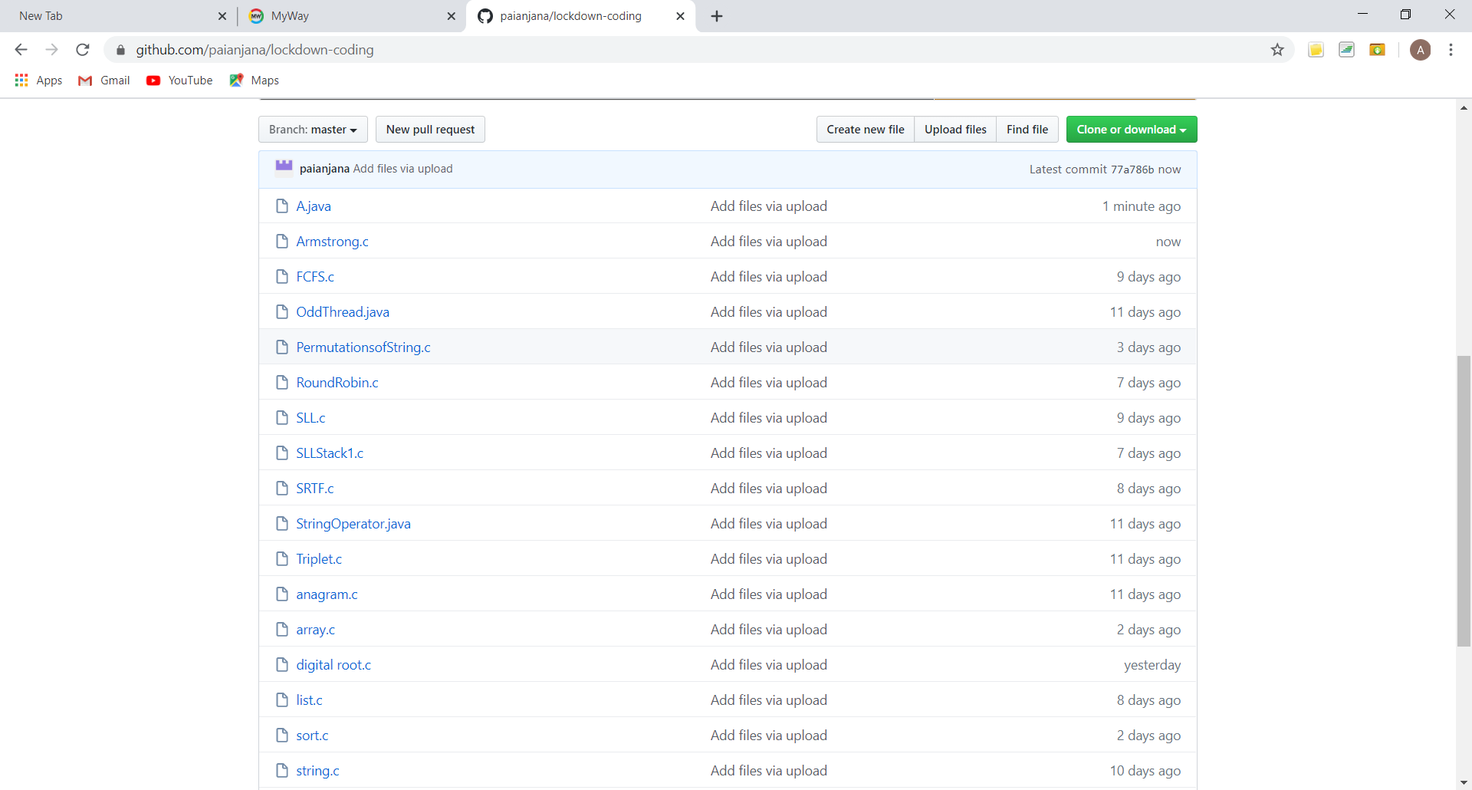

**This is the snap shot of my GitHub repository** where I have uploaded the code. File name is A.java and Armstrong.c